

**MANUAL FOR AIMS ACCOUNT USER**

1. Registration process
2. Login process
3. Add crops process
4. **Registration Process(Creating a account)**

**[Please avoid this step if you are already a registered User of AIMS]**

Note: For a user , they can processes to create their account through Mobile.

**Steps to follow:**

1. Open the app (AIMS) in your mobile **.**
2. Click on the Sign Up button .

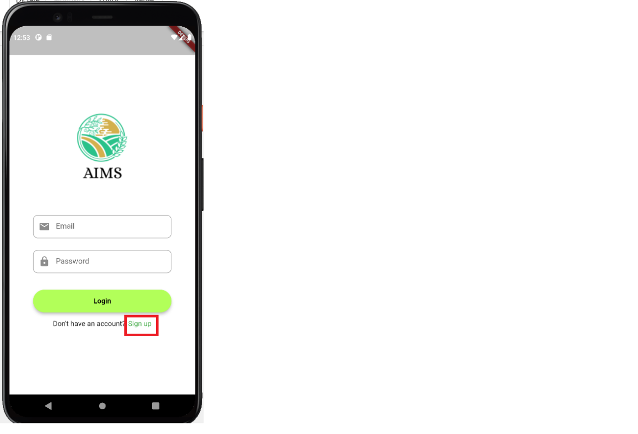

1. After clicking on that red shaded part, you will forward to the screen of sign up page.

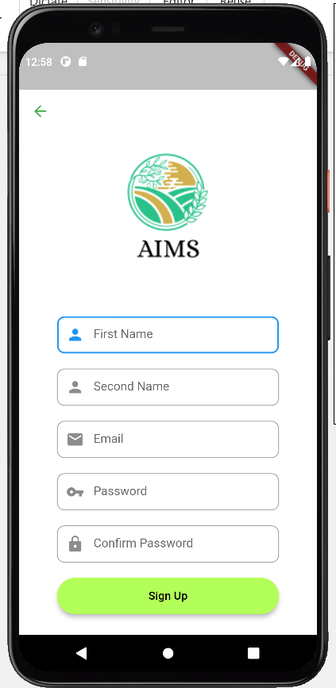

1. 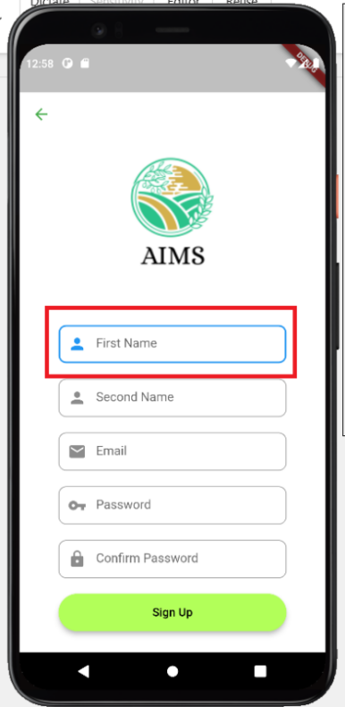In this first form of this page,you need to fill up your first name.
2. As like the Step 4 , you need to fill up all the form respectively taking the guide from the placeholder.
3. After filling up all the requirement, you need to click on that red shaded Sign Up button.

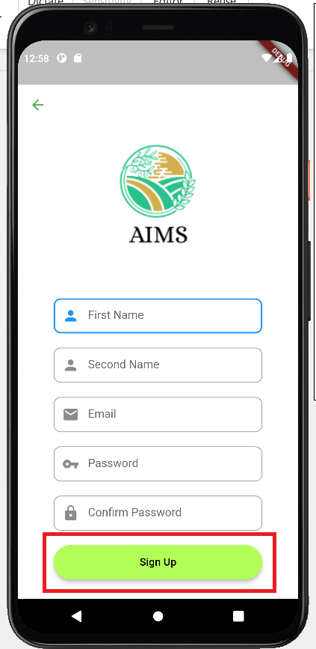

1. After clicking on that Sign Up button, you will forward to Login Page. All you need to do is fill up all the information what you have text in that Sign Up page.
2. When you finished up filling all of the form in login page just click on login button and you will be forwarded to the home page of AIMS.

In this way , you (user) can able to register your account and get a chance to access the features of AIMS .

1. **Login Process**

**[Please For the login process the user need to have already been registered in the app.]**

1. 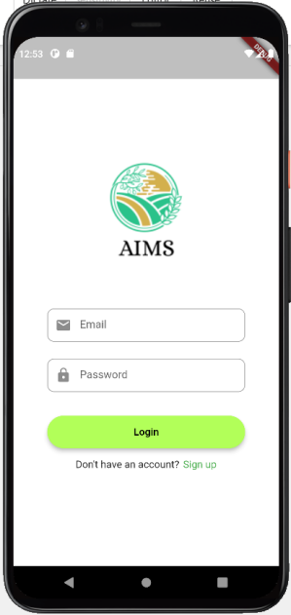First, you need to open the app, the interface is look like as below:

1. You need to fill up the E-mail section with your email address.

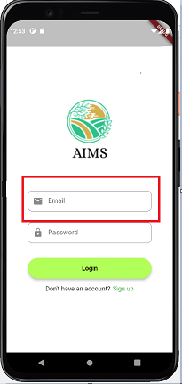

1. As like the step 2, you need to make your password in that section called password.
2. When you finished up filling both the section , you all need to click on that green shaded button called login:

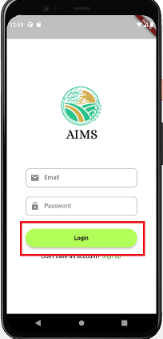

1. Here, you have completed your login process, you will see the below interface after clicking login button:

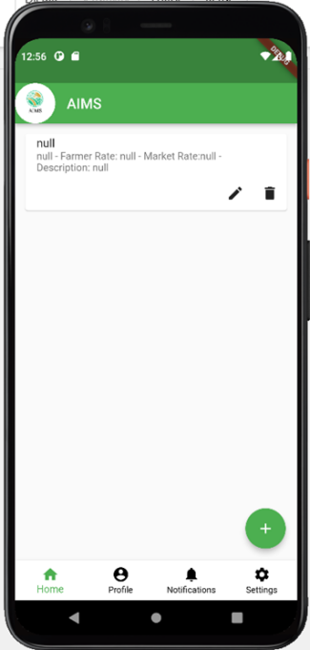

1. **Add Crops Process**
2. This is the homepage of our AIMS system when the user logs in to it. After that when the user clicks on the floating button i.e., the “+” icon which is highlighted by red color the add crops page opens.

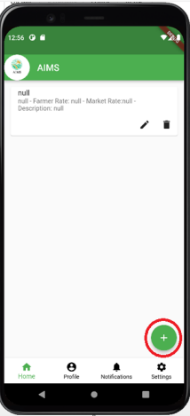

1. By clicking on that page, the user will be forwarded to the next page where they can add the crops, they want by clicking on the floating button which is highlighted in red color.

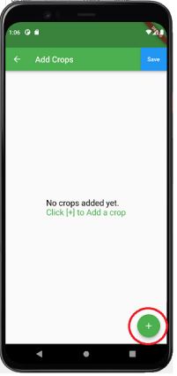

1. On this page, users can add the crop details with some descriptions like Crop name, Crop production, Farmer rate, Market rate, and Crop description.

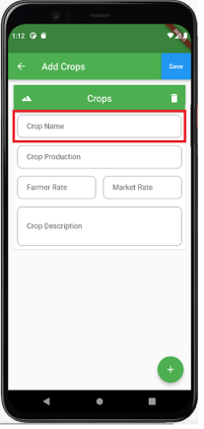

1. Similarly, on the same page after writing the description we must save the details which can be saved by clicking on the save button shown on the right top also for reference we can see the red highlighted part of the application.

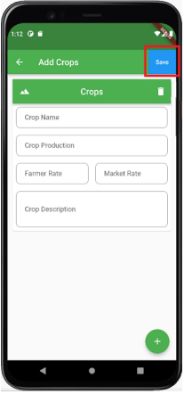

1. Just in case of some details mistake users can delete the crop added by clicking on the delete button, which was saved before, and for help, we can see the photo attached aside in this page highlighted in red color.

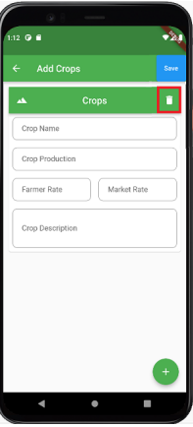

1. After the details have been saved, we can see the details of it on the homepage by clicking in back button placed on the left top of the application.

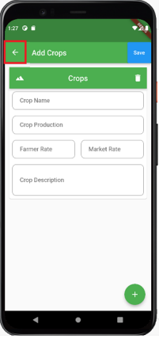

1. After going back to the homepage, we can see the details as follows.

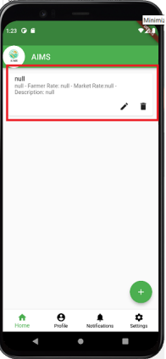

This is the user manual of our app ( Agriculture Information Management System).